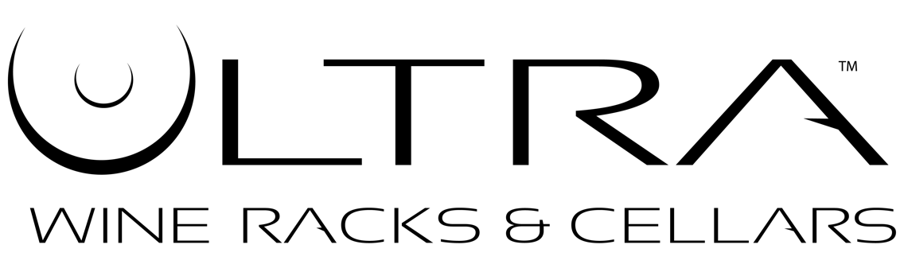
FAQs

FAQ's About:

Our Company

Why Choose Ultra?
Traditional wood racking has a classic, rustic feel to it, but often hides the labels of your wine collection from view. Ultra metal wine racks are designed with a sleek, modern look that brings your collection into the 21st century. Ultra wine racks not only safely and securely store your wine collection, but display it. Many of our products (such as the HZ rails and pegs) are designed to hold your bottles with the labels facing outward for easy viewing.

What types of Ultra wine racks are there?
We’re glad you asked! Feel free to click over to our product pages and browse our product line. Long story short, though, we have three basic types of racks: angled displays (which hold your bottles with the bottom pointing outwards; these displays require a rail or a panel to hold them in place, and are available in our Custom section), cork-out displays (which hold your bottles with the cork pointing outwards), and label-out displays (which hold your bottles parallel to the wall with the labels facing outwards). There are many different types of angled, cork-out, and label-out displays, though, so be sure to browse our site and see them all!

How long will it take to receive my products after I order?
Our products generally ship within 1-3 business days. Transit time is 3-5 business days via FedEx ground. Ultra does not guarantee shipping times.

Who can I contact for product support?
Please call us at 1 (800) 343-9463 ext. 802 or email us at customerservice@ultrawineracks.com.

FAQ's About:

Our Product Installations

Where can I mount Ultra wine racks?
Ultra wine racks are designed to mount on walls, but certain products can also be mounted inside cabinets. Wood, plaster, drywall, concrete—if you have it, an Ultra wine rack will mount to it.

How easy are Ultra products to install? Can I install Ultra products myself or will I need a professional installer?
Our products are easy for anyone to install. Our products come with detailed installation instructions, and installations can usually be accomplished with household tools. In the case of Floor-to-Ceiling racks, you may need a specialized drill to bore a hole in your floor, especially if your floor has a concrete slab foundation.

Will my walls support the weight of my Ultra wine rack when it’s loaded?
Ultra provides the proper mounting hardware and fasteners to distribute the weight on your wall efficiently. Wherever possible, anchor your Ultra wine rack to wall studs.

FAQ's About:

Our Products

What’s the difference between horizontal (HZ) and straight pegs and rails?
Horizontal is just our way of saying “parallel to the wall.” Horizontal (HZ) pegs and rails hold your bottles with the labels facing outward. Straight pegs and rails hold your bottles in a cork-out configuration.

Can Ultra HZ rails hold magnum wine bottles?
Yes, they can, but only in a single-deep configuration.

Are the colors of Ultra products exactly as they’re represented on the website?
Yes. We currently have three options for Floor-to-Ceiling racks, HZ pegs, and HZ rails: satin black, chrome, and wrinkle black. Satin black is glossy, while wrinkle black is slightly textured. Straight pegs and rails come in satin black and chrome. Straight and XL pegs come in brushed aluminum. Max Reveal and straight pegs also come in silver.

Are the faceplates for the Fusion panels interchangeable?
They are, as long as you’re purchasing the same type of faceplate you already have (i.e., HZ or straight). Please call our sales line at 1 (800) 343-9463 ext. 802 to order more Fusion faceplates.

What if I want a five-foot rail or Floor-to-Ceiling?
Simple! Purchase a four-foot rail and a one-foot rail and stick them together with provided plastic couplers and backer channels.

